1. Tampilkan data Name, Region, Population pada tabel Country dan Language berdasarkan Country Population diatas rata-rata

[SELECT](http://localhost/phpmyadmin/url.php?url=https://dev.mysql.com/doc/refman/8.0/en/select.html) country.Name, country.Region, country.Population FROM country, countrylanguage WHERE population > ([SELECT](http://localhost/phpmyadmin/url.php?url=https://dev.mysql.com/doc/refman/8.0/en/select.html) [AVG](http://localhost/phpmyadmin/url.php?url=https://dev.mysql.com/doc/refman/8.0/en/group-by-functions.html#function_avg)(population) FROM country);

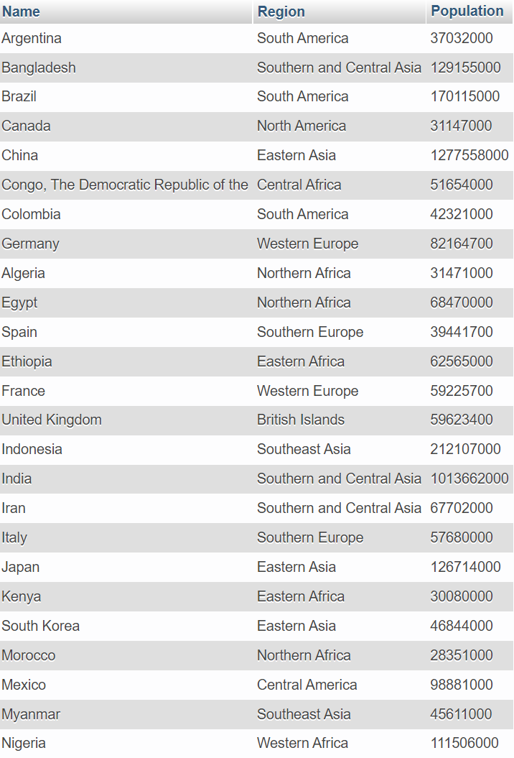

1. Tampilkan data Name, District, Population pada tabel City dan Name Country berdasarkan City Population diatas rata-rata.

[SELECT](http://localhost/phpmyadmin/url.php?url=https://dev.mysql.com/doc/refman/8.0/en/select.html) city.Name, city.District, city.Population FROM city JOIN country ON (city.CountryCode=country.Code) WHERE city.Population > ([SELECT](http://localhost/phpmyadmin/url.php?url=https://dev.mysql.com/doc/refman/8.0/en/select.html) [AVG](http://localhost/phpmyadmin/url.php?url=https://dev.mysql.com/doc/refman/8.0/en/group-by-functions.html#function_avg)(population) FROM city);

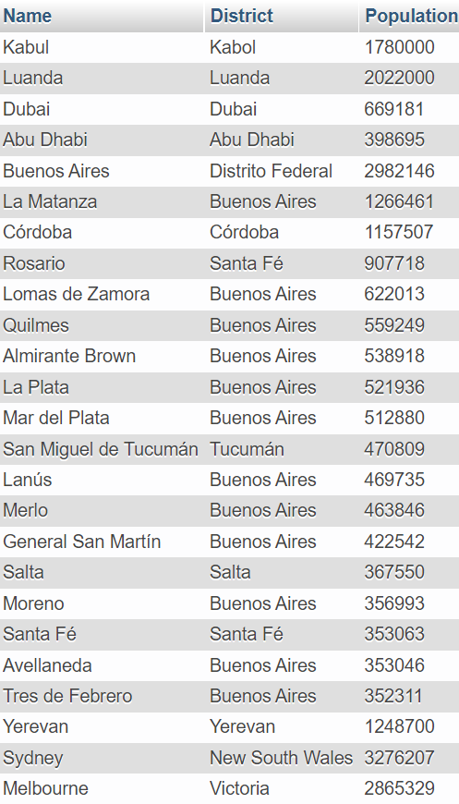

1. Tampilan data Name, Region, Population pada tabel Country berdasarkan IndepYear null

[SELECT](http://localhost/phpmyadmin/url.php?url=https://dev.mysql.com/doc/refman/8.0/en/select.html) Name, Region, Population FROM country WHERE IndepYear [IS](http://localhost/phpmyadmin/url.php?url=https://dev.mysql.com/doc/refman/8.0/en/comparison-operators.html#operator_is) NULL;

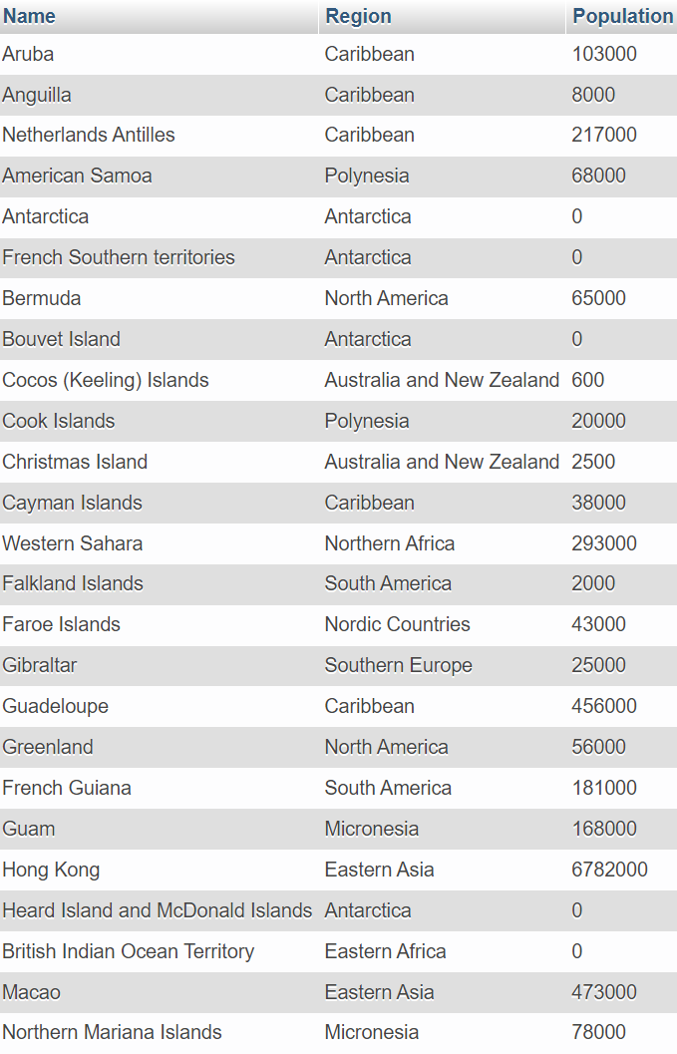

1. Tampilkan data jumlah Country berdasarkan Region yang memiliki Jumlah Country diatas 5

[SELECT](http://localhost/phpmyadmin/url.php?url=https://dev.mysql.com/doc/refman/8.0/en/select.html) Region, [COUNT](http://localhost/phpmyadmin/url.php?url=https://dev.mysql.com/doc/refman/8.0/en/group-by-functions.html#function_count)(Name) AS country FROM country GROUP BY Region HAVING [COUNT](http://localhost/phpmyadmin/url.php?url=https://dev.mysql.com/doc/refman/8.0/en/group-by-functions.html#function_count)(Name) > 5;

